TRAFFIC FLOW OPTIMIZATION SYSTEM FOR URBAN AREAS

BY

SULEIMAN, Danladi Sulei
CSC/22U/4416

OCTOBER, 2026

TRAFFIC FLOW OPTIMIZATION SYSTEM FOR URBAN AREAS

BY

SULEIMAN, Danladi Sulei
CSC/22U/4416

A PROJECT SUBMITTED TO THE DEPARTMENT OF COMPUTER SCIENCE. FACULTY OF PHYSICAL SCIENCES IN PARTIAL FULFILLMENT FOR THE AWARD OF BACHELOR OF SCIENCE DEGREE IN COMPUTER SCIENCE (B.Sc.) OF MODIBBO ADAMA UNIVERSITY YOLA

OCTOBER, 2026

APPROVAL PAGE

This project report entitled “Traffic Flow Optimization System for Urban Areas” meets the regulations governing the award of the degree of (B.Sc.) of the Modibbo Adama University, Yola and is approved for its contribution to knowledge and literary presentation.

________________________ ____________________
Mr. A.I Muhammad Date
(Supervisor)

________________________ ____________________
Dr. Y. M. Malgwi Date
(Head of the Department)

________________________ ____________________
External Examiner Date

DEDICATION
This work is dedicated to God Almighty, for His wisdom, guidance, and strength throughout the course of this project. It is also dedicated to my family and loved ones for their unwavering support and encouragement.

ACKNOWLEDGEMENTS
I sincerely acknowledge the Almighty God for His grace and strength in completing this work. I express my profound gratitude to my supervisor, Mr. A.I Muhammad for his/her guidance, corrections, and support throughout this project. I also appreciate my lecturers in the Department of Computer Science for their academic contributions and knowledge imparted during my study.
My heartfelt appreciation goes to my family and friends for their encouragement, moral support, and understanding during the course of this work.
Finally, I acknowledge all authors and researchers whose works were consulted in the course of this study.

ABSTRACT
The developed Traffic Flow Optimization System successfully demonstrates the feasibility of density-based dynamic signal timing for Nigerian urban intersections (Antuley, 2024; Akhilomhen, 2025). The system's ability to allocate green time in proportion to detected vehicle densities provides significant improvements over fixed-time signal control (Zhang & Li, 2024; Xu & Chen, 2022). The density-based optimisation algorithm is effective across a range of traffic demand levels, with performance improvements becoming more pronounced as traffic demand increases (Agrawal & Sharma, 2022). This suggests that the system is particularly beneficial for managing peak-period congestion (Jiang & Lee, 2023; Li & Wang, 2023). The three-tier architecture employed in the system provides appropriate separation of concerns and supports maintainability and future enhancement (de Souza et al., 2017). The modular design enables independent development and evolution of system components (Chen & Liu, 2022; Zhao & Liu, 2021). The use of open-source technologies including Python, Flask, and SQLite provides a cost-effective platform for traffic optimisation system development (Antuley, 2024). The accessibility of these technologies supports the goal of developing locally-relevant solutions that can be deployed in resource-constrained settings (Adebayo & Ogunlade, 2023; Okafor & Nwosu, 2023). The performance improvements demonstrated in this study support the case for investment in intelligent traffic management systems in Nigerian urban areas (World Bank, 2024; Federal Ministry of Works and Housing, 2024). The benefits of reduced delay, increased throughput, and shorter queue lengths translate to practical improvements in travel times, fuel consumption, and quality of life (Oladimeji & Adebayo, 2024; Gbadamosi & Adebayo, 2025).

APPROVAL PAGE iii
DEDICATION iv
ACKNOWLEDGEMENTS v
CHAPTER ONE 1
INTRODUCTION 1
1.1 Background of the Study 1
1.2 Motivation of the Study 2
1.3 Aim and Objective of the Study 2
1.4 Significance of the Study 3
1.5 Scope of the Study 3
1.6 Limitation of the Study 3
1.7 Operational Definition of Terms 3
CHAPTER TWO 5
LITERATURE REVIEW 5
2.1 Introduction 5
2.2 Information Sharing Among Agencies and Management Centers 5
2.3 Transportation Systems Management (TSM) Relationship 6
2.4 Control System Options 8
2.5 Implications of Intelligent Traffic System 8
2.5.1 Intelligent Traffic System for safety 8
2.5.2 Intelligent Traffic System for efficiency and economy 9
2.5.3 Intelligent Traffic System for environment 10
2.5.4 Intelligent Traffic System for Security 11
2.5.5 Intelligent Traffic System in urban public transport system 11
2.6 Benefits of Intelligent Traffic System in Urban Public Transport Systems 12
2.7 Rules of Intelligent Traffic Control 12
2.8 Vehicle Control 13
2.9 Expert Systems 14
2.10 Prediction-Based Optimization 14
CHAPTER THREE 16
METHODOLOGY 16
3.1 Introduction 16
3.2 Study Area 16
3.3 Analysis of Existing System 17
3.4 Problems of Existing System 19
3.4.1 Irregular Timing 19
3.4.2 Excessive Waiting Time 19
3.4.3 Human Errors 19
3.4.4 Traffic Congestion 19
3.4.5 Accident Risks 20
3.4.6 Lack of Real-Time Traffic Monitoring 20
3.4.7 Inefficient Utilization of Road Capacity 20
3.5 Description of the Proposed System 20
3.5.1 Operation of the Proposed System 20
3.5.2 Traffic Density Detection 21
3.5.3 Automatic Signal Timing Adjustment 22
3.5.4 Benefits of the Proposed Automated System 22
3.5.5 Objectives of the Proposed System 22
3.4 Merit of the Proposed System 23
3.5 Feasibility Study 23
3.6 Input Analysis 23
3.7 Output Analysis 25
3.8.1 Hardware Requirements 27
3.8.2 Software Requirements 28
3.9 System Flowchart 29
3.10 System Design and Implementation 32
CHAPTER FOUR 33
RESULTS AND DISCUSSION 33
4.1 System Implementation 33
4.2 System Testing 35
4.3 Results Analysis 36
4.4 Discussion of Results 40
CHAPTER FIVE 43
SUMMARY, CONCLUSION AND RECOMMENDATIONS 43
5.1 Summary 43
5.2 Conclusion 44
5.3 Recommendations 45
5.4 Contributions to Knowledge 47
REFERENCES 48

CHAPTER ONE

INTRODUCTION

1.1 Background of the Study
The increase in urbanization and traffic congestion creates an urgent need to operate our transportation systems with maximum efficiency. Real-time traffic signal control is an integral part of modern Urban Traffic Control Systems aimed at achieving optimal Utilization of the road network. Providing effective real time traffic signal control for a large complex traffic network is an extremely challenging distributed control problem. Signal system operation is further complicated by the recent trend that views traffic signal system as a small component of an integrated multimodal transportation System. Optimization of traffic signals and other control devices for the efficient movement of traffic on streets and highways constitutes a challenging part of the advanced traffic management system of intelligent transportation system. Simply defined, Intelligent Transport Systems integrate communication technologies, sensors, vehicles and transport infrastructure to improve traffic efficiency and safety (Zhang et al., 2021).
For a large-scale traffic management system, it may be difficult or impossible to tell whether the traffic network is flowing smoothly and assess its current state.
Over the past few years, multi-agent systems have become a crucial technology for effectively exploiting the increasing availability of diverse, heterogeneous and distributed information sources. Researchers over the Years have adopted numerous techniques and used various tools to implement multi-agent systems for their problem domains. As researchers gain a better understanding of these autonomous multi-agent systems, more features are incorporated into them to enhance their performance and the enhanced systems can then be used for more complex application domains. Intelligent software agent is an autonomous computer program, which interacts with and assists an end user in certain computer related tasks. In any agent, there is always a certain level of intelligence.
The level of the Intelligence could vary from pre-determined roles and responsibilities to a learning entity. Multi-Agent System is the aggregate of agents, whose object is to decompose the large system to several small systems which communicate and coordinate with each other and can he have extended easily. Agent-based simulations are models where multiple entities sense and stochastically respond to conditions in their local environments, mimicking complex large scale system behavior. Urban traffic systems are highly dynamic and complex networks that require intelligent and adaptive control strategies (Wang et al., 2022).
Therefore, the most important issues for a learner agent is the assessment of the behavior and the intelligence level of the other agents. By sharing vital information, Intelligent Traffic System allows people to get more from transport networks, with greater safety and with less impact on the environment. Intelligent Traffic System helps the whole transport system to work most effectively and efficiently. Intelligent Traffic System integrates users, transport systems, and vehicles through state-of-the-art information and communications technologies. Intelligent Traffic System can dramatically improve travelers’ safety, efficiency and comfort. Intelligent Traffic System helps shippers and carriers move freight to its destination reliably and efficiently. Intelligent Traffic System helps the people who run transport systems provide better service to their customers. Intelligent Traffic System helps get the best value from the road and rail systems we already have. Intelligent Traffic System helps traffic flow more smoothly, reducing delays, fuel consumption, and air and noise pollution. Intelligent Traffic System helps make public transport more convenient and affordable. Intelligent Traffic System often works behind the scenes. When emergency vehicles get to a crash site more rapidly than before, Intelligent Traffic System is detecting the crash, notifying emergency services, and getting the nearest response unit rapidly to the site. Modern ITS technologies significantly improve safety, congestion management and emergency response services (Abduljabbar et al., 2021).

1.2 Motivation of the Study
Traffic congestion is an increasing problem in cities and sub urban spend more of their time commuting to work, school, shopping, and social event as well as dealing with traffic light jambs and accidents. Traffic became heavy in all directions, more to and from cities as well as between sub urban locations. Sub urban business locations required huge parking lots because employees have to drive; there were few buses trains, or trolleys to carry scatter workers to their work place. The hope of reduced congestion in the sub urban had not been realized; long commutes and traffic jams could be found everywhere.

1.3 Aim and Objective of the Study
The aim of this research is to provide travel opportunities and additional travel choices for more people in more ways, wherever they live, work and play, regardless of age or disability. In achieving this aim, the following objectives will also be followed to:

- design a simple system that is easily adaptable to the existing traffic conditions at the junction, involving a minimum of physical changes in the intersection.
- provide the quickest possible clearance to vehicular and pedestrian traffic in all directions at a junction.
- design flexible artificial intelligence traffic light system that will take care of changes in the traffic density and character.

1.4 Significance of the Study
The important of this research work are:
It will help in reducing the occurrence of possible collision or accident and thereby improve the confidence of the driver and the pedestrian plighting through the highways. The project to allay the fear of time wastage at the junctions because of unevenly directions of traffic system. Since the system is capable of working for 24hours uninterrupted thereby assured constant availability of traffic control service hence reduce human effort and energy.

1.5 Scope of the Study
The scope is the design of an intelligent traffic control system. The modern method of traffic control system is indicating each light at a particular time interval to pass a vehicle at one lane and stop vehicle on the other lane. The light is broken into three (3) categories (Red, Yellow, and Green) to signal to lane on what to do at a particular time where the red signify STOP, yellow signify READY, and green signify MOVE. Each light is designed to turn itself on whenever it is necessary and turn off the time elapse.

1.6 Limitation of the Study
Traffic congestion is a serious problem despite costly effort to create an integrated method of traffic control system. The number of private automobiles used mainly by people with middle and income, has increased faster than any form of transportation in Lagos (Nigeria) and this has increased a demand of expansion of roads, parking space and improved computerized traffic control system.

1.7 Operational Definition of Terms
Traffic Light: A road signal for directing vehicular traffic by means of colour lights, typically red for stop, green for go, and yellow for proceed with caution.
Intelligent Traffic System: This refers to information and communication technology Â that improve transport outcomes such as transport safety, transport productivity, travel reliability, informed travel choices, social equity, environmental performance and network operation resilience.

CHAPTER TWO

LITERATURE REVIEW

2.1 Introduction
Transportation research has the goal to optimize transportation flow of people and Goods. As the number of road users constantly increases, and resources provided by current infrastructures are limited, intelligent control of traffic will become a very important issue in the future. However, some limitations to the usage of intelligent traffic control exist. Avoiding traffic jams for example is thought to be beneficial to both environment and economy, but improved traffic-flow may also lead to an increase in demand. There are several models for traffic simulation. In our research we focus on microscopic models that model the behavior of individual vehicles, and thereby can simulate dynamics of groups of vehicles. Deep learning and reinforcement learning models have demonstrated improved performance in urban traffic prediction and signal optimization (Gu et al., 2020).
Cars in urban traffic can experience long travel times due to inefficient traffic light control. Optimal control of traffic lights using sophisticated sensors and intelligent optimization algorithms might therefore be very beneficial. Optimization of traffic light switching increases road capacity and traffic flow, and can prevent traffic congestions.
Traffic light control is a complex optimization problem and several intelligent algorithms, such as fuzzy logic, evolutionary algorithms, and reinforcement learning (RL) have already been used in attempts to solve it. Multi-agent reinforcement learning has become one of the leading approaches for adaptive traffic signal control (Wei et al., 2021).

2.2 Information Sharing Among Agencies and Management Centers
Information is commonly shared among agencies by means of voice communications and data communications. The Regional Intelligent Traffic System Architecture establishes the general data flow requirements between agencies and from each agency’s management center to the field equipment or other equipment that it communicates with or controls. To perform data communication between management centers, a common language and frame of reference is required. In essence, the information may be put into the proper high level language by the use of the Traffic Management Data Dictionary (TMDD). The TMDD provides the definition and format for the data and the Message Sets for External Traffic Management Communications (MS / ETMCC) which organizes the TMDD elements into relevant messages. Modern intelligent transportation systems rely on real-time data sharing among agencies using cloud and IoT platforms (Khan et al., 2021).

2.3 Transportation Systems Management (TSM) Relationship
Since first introduced in the mid-1970s, transportation systems management
(TSM) has evolved from a list of about 150 low-cost actions to the productive use of existing transportation resources through their coordinated operations and improved management. TSM implies "a philosophy about planning, programming, implementation, and operations that calls for improving the efficiency and effectiveness of the transportation system by improving the operations and / or services provided". Transportation Systems Management focuses on optimizing existing transport infrastructure through intelligent control and coordination (FHWA, 2022). TSM, then, provides an umbrella philosophy that aims to:
- Analyze the total system, and
- Improve operation and safety before capital-intensive projects add significant capacity.
Roark classifies TSM actions within 9 different urban operating environments, including:
- Freeway corridor,
- Arterial corridor,
- Central business district (CBD),
- Regional operating environment,
- Neighborhood,
- Major employment site (non-CBD),
- Outlying commercial center,
- Major activity center, and
- Modal transfer point.
In contrast, Wagner uses two primary strategies - supply and demand (6). Supply strategies focus on changing the quality of vehicular flow, whereas demand-oriented strategies target decreasing the quantity of vehicular travel.

Supply actions include:
- Arterial signal coordination,
- Signal removal or flashing operation,
- Freeway monitoring and control,
- Incident management,
- Parking prohibition,
- Turn controls, and
- Bottleneck-removal programs.
Demand actions include:
- Carpools,
- Vanpools,
- High occupancy vehicle (HOV) priority treatments, and
- Variable work hours.
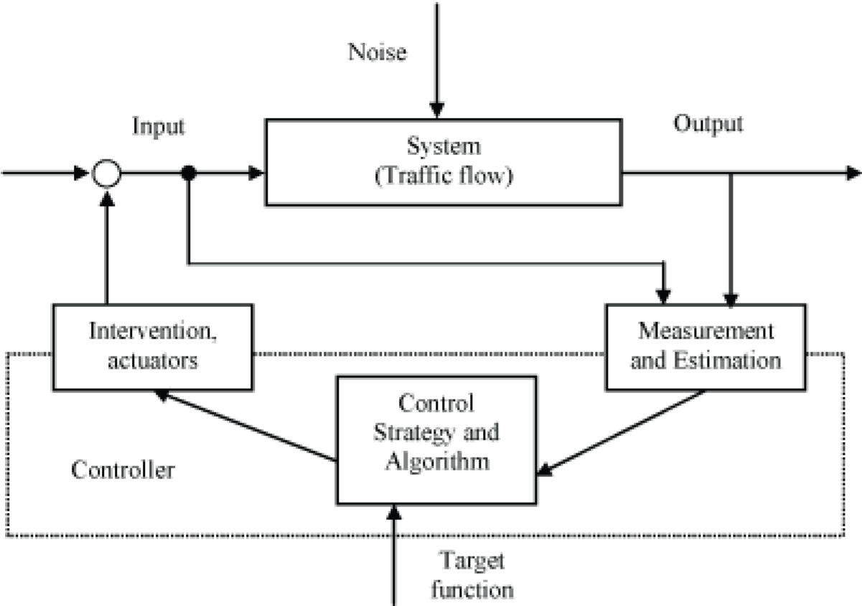
In both classification schemes, traffic control systems and their effective operation predominantly affect TSM and prove vital to the full realization of several other TSM actions. For example, it does little good to entice drivers to ride the bus or join a vanpool if inefficiently operating traffic signals stop or delay all vehicles (including buses and vans).
Figure 2.3: General traffic management and control structure.

2.4 Control System Options
Operational objectives of traffic control systems include making the best use of existing roadway and freeway network capacity and reducing trip times, without creating adverse environmental impacts. Controlling the movement of vehicles through signalized intersections provides the major effect on traffic flow in urban areas. Adaptive signal control strategies improve traffic flow and reduce congestion in urban intersections (Liu et al., 2021).

2.5 Implications of Intelligent Traffic System

2.5.1 Intelligent Traffic System for safety
More than 40,000 people die on Europe’s roads each year. Road accidents cost the European economy around €200 billion each year. Intelligent transportation systems significantly reduce accidents through real-time monitoring and vehicle communication technologies (Younes et al., 2020). Intelligent Traffic System can help reduce injuries and save lives, time and money by making transport safer:
- Intelligent Traffic System will help the drivers of cars, trucks and buses avoid getting into crashes and help keep them from running off the road. Intelligent Traffic System will help maintain safe distances between vehicles and safe speeds approaching danger spots. Intelligent Traffic System will help improve visibility for drivers, especially at night and in bad weather.
- Intelligent Traffic System will provide information about work zones, traffic congestion, road conditions, pedestrian crossings and other potential hazards.
- Intelligent Traffic flow System will help detect the crashes that do occur, determine the severity of the crash and likely injuries, and help emergency management services provide assistance. Intelligent Traffic System will help select the closest and most appropriate rescue unit to respond. Intelligent Traffic System will adjust traffic signals to clear the way for emergency vehicles.
- Intelligent Traffic flow System will connect responding units to medical care facilities to help provide initial care for the injured and help medical care facilities prepare to deliver more complete treatment when injured people arrive.

2.5.2 Intelligent Traffic System for efficiency and economy
Congestion costs the EU 1% of its GDP – around €100 billion – each year. There are around 300 million drivers in the EU today, while in the past 30 years the distance travelled by road has tripled and is set to increase further. With funding and space for large-scale road building becoming increasingly scarce, governments, infrastructure operators and pubic authorities are turning to Intelligent Traffic System solutions to ease congestion. Smart traffic systems reduce congestion costs and improve transportation efficiency through data-driven control mechanisms (Alghamdi et al., 2022). Intelligent Traffic System can save time and money for travelers and the freight industry:
- Intelligent Traffic System will deliver fast, accurate and complete travel information to help travelers decide whether to make a trip, when to start, and what travel modes to use. Intelligent Traffic System will provide his information both prior to a trip and as the trip proceeds.
- Intelligent Traffic System will help drivers select and follow safe, efficient routes to their destination. Intelligent Traffic System will let drivers pay tolls without having to stop.
- Intelligent Traffic System will help freight move swiftly and reliably using the right combination of ship, truck, train and plane.
- Intelligent Traffic System will help track freight, enabling its owners to know where it is at all times and when it is due to arrive at its destination, and allowing for better planning and scheduling of critical processes.
- Intelligent Traffic System will enable more reliable and timely commercial vehicle management. Intelligent Traffic System will automatically keep track of safety-related information about the vehicle, its driver and its cargo. Intelligent Traffic System will help communicate this information to the authorities so that, as appropriate, vehicles can be cleared through checkpoints without stopping.
- Intelligent Traffic System will help the people who build, manage and maintain the transport system. Intelligent Traffic System will help the transport system carry more traffic safely and efficiently by keeping traffic flowing, clearing incidents quickly, and managing construction and maintenance to minimize disruptions. Intelligent Traffic System will help schedule road management vehicles and help them work more precisely and efficiently.
The next generation of Intelligent Traffic System solutions will:
- Give public transport users real-time service information, as well as smart and seamless ticketing solutions.
- Enable freight operators and customs authorities to share information about consignments and keep track of their position and status, as well as provide information on the most efficient, economical and secure routes for freight.
- Allow vehicles to communicate directly with the infrastructure around them and with one another – enabling drivers to make better decisions about their route and respond to warnings of congestion and accidents.

2.5.3 Intelligent Traffic System for environment
Despite increasing air travel, the vast majority of this energy is still consumed by road transport. Since Intelligent Traffic System systems can improve the efficiency of passenger and goods transport and reduce the time caught in traffic congestion, they will obviously have secondary benefits for the environment and in terms of use of space:
- Intelligent Traffic System will keep traffic flowing on urban freeways, on toll roads, at commercial vehicle checkpoints and elsewhere. Reducing delays due to congestion and incidents means that energy waste, wear–and– tear, and the pollution caused by stop–and–go driving are also reduced.
- Intelligent Traffic System will help vehicles operate more efficiently. Intelligent Traffic System will provide location–specific information about weather and road conditions.
- Intelligent Traffic System will help to plan efficient routes and guide drivers along these routes.
- Intelligent Traffic flow System will help make public transport more reliable, effective and attractive, thereby accelerating its use. Intelligent Traffic System will provide better information on schedules and connections. Intelligent Traffic System will help public transport users stay in touch with their employers and their families while in transit.

2.5.4 Intelligent Traffic System for Security
Recent events have shown that the transport system is under threat from terrorism, whether as a target in itself or a means of attacking other targets. The need to protect travelers, transport facilities and transport workers against security risks has never been greater. However, this must be balanced with the need to make sure transport continues to operate effectively and efficiently. Intelligent
Smart traffic systems reduce congestion costs and improve transportation efficiency through data-driven control mechanisms (Alghamdi et al., 2022). In fact, Intelligent Traffic System will help prepare for, prevent and respond to disaster situations, whether from natural causes, human error, or attacks:
- Intelligent Traffic System will help keep watch over transport facilities.
- Intelligent Traffic System will help provide personal security for people using the public transport system.
- Intelligent Traffic System will monitor freight, especially hazardous materials, through the entire supply chain.
- Intelligent Traffic System will help transport and safety/security agencies coordinate their activities and their information so they can respond more effectively to incidents of all kinds.
- Intelligent Traffic System will help identify the best routes for evacuating people at risk and for directing emergency services to incidents and disaster sites.
- Intelligent Traffic System will help the transport system, and all the other parts of the economy that depend on transport, to return to normal as rapidly as possible following a crisis, through better management of the transport system, more efficient interagency communications, and better and more timely information to the public.
- Intelligent Vision Systems can automatically spot suspicious behavior at transport hubs, while automatic tracking and alarm systems can speed the response to threats.

2.5.5 Intelligent Traffic System in urban public transport system
Intelligent transport systems in urban public transport might be described as a combination of information and communication technologies integrated into urban public transport system. Smart public transport systems integrate IoT and real-time information services to improve passenger mobility (Aifadopoulou et al., 2021). At present, public-sector infrastructure, including electronic toll collection and road use charging, still represents the largest Intelligent Traffic System market segment. In the future, private sector purchases of Intelligent Traffic System products and services (either from commercial and consumers) are expected rapidly to overtake the public sector market, with emphasis on communications- enabled in-vehicle products and services, reflecting rapid growth in the wireless internet. Recent studies demonstrate the effectiveness of intelligent traffic management in developing urban environments (Adeyemi et al., 2023).

2.6 Benefits of Intelligent Traffic System in Urban Public Transport Systems
Application of Intelligent Traffic System in urban transport can lead to an improvement of urban transport performance through:
- Reductions in transport time, cost, and congestion
- Reductions in pollution
- More effective monitoring and management of traffic flows
- Greater safety and security in stations, streets, roads and vehicles
- Facilitation of multimodal journey planning
- Provision of real time traffic information, alternate routes, etc.
- Creation of appropriate travel conditions for disabled people.

2.7 Rules of Intelligent Traffic Control
Here are a few samples of the types of rules that might be employed at a couple levels of an intelligent system.
Individual traffic light:
- If the time of day is between A and B then red on time is X, yellow on time is Y and green on time is Z.
- If direction A is green and direction A number of cars visible is very low and direction B is red and direction B number of cars visible is very high then trigger direction A to red and trigger direction B to green.
- If direction A weighted average wait time is greater than direction B weighted average wait time then incrementally increase within limits the direction A green on time and decrease, within limits, direction B green on time.

2.8 Vehicle Control
It is a well-known fact that traffic flow would increase drastically if all drivers would drive at the same (maximum) speed. Another fact is that this will never happen if you let drivers decide. In this section we first show how vehicles could learn to cooperate. We then describe an ambitious research program that aims to control all vehicles by on-board computers. Connected and autonomous vehicles can improve traffic flow through cooperative driving mechanisms (Talebpour et al., 2021).
Their approach enabled cars to learn lane selection strategies from experience with a traffic simulator. Experimental studies showed that learned strategies let drivers more closely match their desired speeds than hand-crafted controllers and reduce the number of lane changes. Their approach, like ours, focuses on distributed car-based controllers, which makes it easy to take specific desires/goals of drivers into account such as desired speed or destination.
In the California Partners for Advanced Transit and Highways (PATH) program, the Automated Highway System (PATH-AHS) project aims to completely automate traffic (Di-Febbraro, 2024). Cars on special roads would travel in so-called platoons. A platoon is a number of cars that travel at high speed, with little distance in between. Each car controls its own speed and lateral movement, and makes sure it follows the leader. The leader navigates the platoon, and makes sure that there is enough space between platoons. In order to optimize flow, a platoon leader receives information about the optimal speed from a roadside coordinating system. Because of this, and the fact that there is little distance in between cars in a platoon, an AHS is said to be able to increase road capacity by a factor of about four. Another aspect of traffic control is controlling traffic lights in a way that minimizes the time drivers have to wait. We will describe previous research in this area and our car-based, multi-agent reinforcement learning algorithm in section 4. Decentralized traffic routing algorithms have shown improved congestion reduction in smart cities (Zhao et al., 2022).
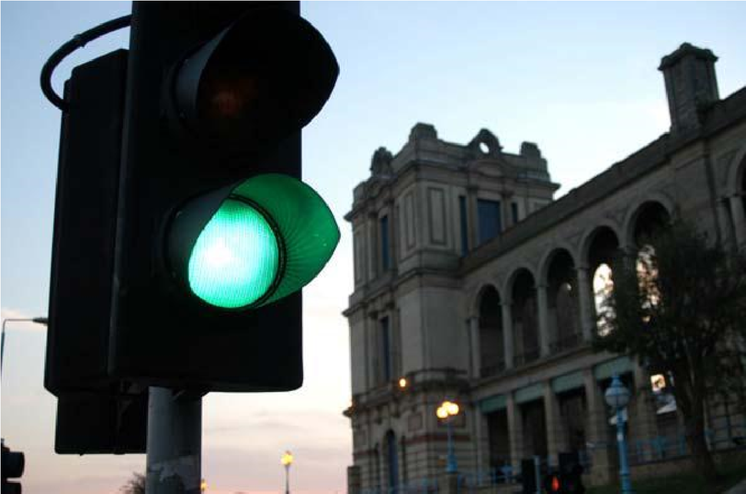

F
ig 2.7 Traffic control light

2.9 Expert Systems
An expert system uses a set of given rules to decide upon the next action. In traffic light control, such an action can change some of the control parameters. Artificial intelligence and expert systems continue to play important roles in adaptive traffic signal control (Singh et al., 2021). The expert systems can communicate to allow for synchronization. Performance on the network depends on the rules that are used. For each traffic light controller, the set of rules can be optimized by analyzing how often each rule fires, and the success it has. The system could even learn new rules. Findler and Stapp showed that their system could improve performance, but they had to make some simplifying assumptions to avoid too much computation.

2.10 Prediction-Based Optimization
Prediction-based traffic signal optimization using machine learning improves intersection performance (Zheng et al., 2021). Measurements taken during the current cycle are used to test several possible settings for the next cycle, and the setting resulting in the least amount of queued vehicles is executed.
The system seems highly adaptive, and maybe even too much so. Since it only uses data of one cycle, it could not handle strong fluctuations in traffic flow well. In this case, the system would adapt too quickly, resulting in poor performance.
Reinforcement learning approaches provide fair and efficient signal timing decisions in urban traffic networks (Wei et al., 2021). Traffic detectors at both sides of a junction and vehicle identification are used to measure delay of vehicles at a junction. This is projected to an estimated average delay time using a filter function to smooth out random fluctuations. The control system tries to minimize not only the total delay, but the summed deviations from the average delay as well. Since it is no longer beneficial to let a vehicle wait for a long time, even if letting it pass would increase the total waiting time, this introduces a kind of fairness. Data of about 15 minutes is used to determine the optimal settings for the next cycle, and even using a simple optimization algorithm, the system performs well compared to preset and actuated controllers.

CHAPTER THREE

METHODOLOGY

3.1 Introduction
System analysis / investigation and design of the proposed system are necessary in order to produce the required system needed for effective running of the organization. Imperatively the boundary of the new system and its limitation are also produced to see its measure of effectiveness and ineffectiveness as regulate its relationship either with its domain or other department of the organization.

3.2 Study Area
The study area for this research is the urban road transportation environment characterized by high vehicular movement, traffic congestion, and signalized intersections. Urban areas in Nigeria experience increasing traffic challenges as a result of rapid population growth, urbanization, inadequate road infrastructure, and increasing ownership of private vehicles.
The study focuses on traffic flow conditions at major road intersections and junctions where traffic congestion frequently occurs. Such intersections are usually controlled either by traffic wardens or fixed-time traffic lights that often fail to respond effectively to changing traffic conditions. As a result, road users experience excessive delays, long queues, increased fuel consumption, and a higher risk of road accidents.
Urban road networks consist of interconnected roads, highways, and junctions that facilitate the movement of vehicles, goods, and pedestrians. These networks are commonly affected by peak-hour congestion, especially in commercial and residential areas where traffic demand exceeds road capacity.
Signalized intersections constitute an important component of urban transportation systems because they regulate vehicle movement and reduce conflicts between road users. However, conventional traffic signals operate using fixed timing mechanisms that may not adequately accommodate variations in traffic density. Consequently, certain roads may experience unnecessary waiting times while other lanes remain underutilized.
The Nigerian urban traffic environment presents unique challenges such as poor traffic management, inadequate monitoring systems, non-compliance with traffic regulations, and insufficient intelligent transportation infrastructure. These challenges contribute significantly to traffic congestion in many cities.
Therefore, this study concentrates on developing a traffic flow optimization system capable of improving traffic management at urban intersections through intelligent control mechanisms. The proposed system is intended to reduce traffic delays, improve traffic movement efficiency, minimize congestion, and enhance road safety within urban environments.

3.3 Analysis of Existing System
The existing traffic control system used in many urban areas operates primarily through manual traffic management and fixed-time traffic signal systems. Traffic wardens and conventional traffic lights are commonly employed to regulate vehicle movement at road intersections and busy junctions. Although these methods have been effective to some extent, they possess several limitations that contribute to traffic congestion and inefficiency.
Existing Traffic Light Operations
Most traffic intersections operate using predetermined traffic signal timings. The duration of the red, yellow, and green lights is fixed regardless of the actual traffic volume on each road. The traffic lights operate according to programmed schedules without considering real-time traffic conditions.
During periods of low traffic density, vehicles may still experience unnecessary waiting times because the signal timing remains unchanged. Similarly, during peak traffic periods, fixed signal durations may not provide sufficient green time for heavily congested roads, resulting in long queues and traffic delays.
Manual Traffic Control
In many Nigerian cities, traffic officers are deployed at busy intersections to manually control vehicle movement. Traffic wardens direct vehicles using hand signals and personal judgment to manage traffic flow, especially during traffic congestion, road construction, special events, or when traffic lights malfunction.
Although manual traffic control provides flexibility, it has several disadvantages. Human errors, fatigue, poor judgment, and inconsistency in decision-making may negatively affect traffic operations. In addition, traffic wardens may find it difficult to effectively manage large traffic volumes during peak periods.

Fixed-Time Signal Systems
Fixed-time traffic signal systems allocate equal or predetermined signal durations to all traffic approaches irrespective of traffic demand. These systems do not possess the ability to monitor traffic density or automatically adjust signal timings according to traffic conditions.
As a result, some roads may receive green signals when very few vehicles are present, while heavily congested lanes experience prolonged waiting times. This inefficient allocation of signal time contributes to increased traffic congestion and reduced road capacity utilization.
Problems Encountered in the Existing System
The analysis of the existing traffic control system reveals several challenges, which include:
- Traffic Congestion: Fixed signal timing often leads to long vehicle queues and delays at intersections.
- Excessive Waiting Time: Vehicles experience unnecessary delays due to the inability of the system to adapt to changing traffic conditions.
- Human Errors: Manual traffic control depends heavily on the judgment and performance of traffic officers, which may result in mistakes.
- Inefficient Traffic Flow: Equal signal timing for all directions does not reflect actual traffic demand.
- Increased Fuel Consumption: Vehicles spend longer periods idling at intersections, leading to increased fuel usage.
- Environmental Pollution: Traffic congestion contributes to higher vehicle emissions and environmental pollution.
- Poor Emergency Response: Emergency vehicles may experience delays due to inefficient traffic management.
- Lack of Real-Time Monitoring: The existing system cannot detect traffic density or automatically adjust signal operations.
Therefore, the shortcomings identified in the existing traffic management system necessitate the development of an intelligent traffic flow optimization system capable of adapting signal timings according to real-time traffic conditions and improving the overall efficiency of urban transportation.

3.4 Problems of Existing System
The investigation and analysis of the existing traffic control system revealed several shortcomings that negatively affect traffic management and road transportation efficiency. The major problems identified are discussed below.

3.4.1 Irregular Timing
The existing traffic signal system operates using fixed signal durations that do not consider the actual volume of vehicles on each road. As a result, some roads receive green signals for unnecessarily long periods while heavily congested roads receive inadequate green time. This irregular timing leads to poor traffic distribution and inefficient use of road facilities.

3.4.2 Excessive Waiting Time
One of the major problems associated with the existing system is excessive waiting time experienced by motorists at intersections. Vehicles are often forced to wait even when there is little or no traffic on other approaches. During peak traffic periods, long queues are formed because the signal timing cannot adjust automatically to changing traffic conditions.
Excessive delays increase travel time, reduce productivity, and create frustration among road users.

3.4.3 Human Errors
Manual traffic control relies heavily on traffic officers to regulate vehicle movement. Human factors such as fatigue, lack of concentration, poor judgment, and communication errors may negatively affect traffic management.
Traffic wardens may also find it difficult to effectively control traffic during periods of heavy congestion, adverse weather conditions, or emergency situations. Such human errors can result in traffic confusion and delays.

3.4.4 Traffic Congestion
The inability of the existing system to respond to real-time traffic conditions contributes significantly to traffic congestion. Long vehicle queues frequently develop at busy intersections because the system allocates equal signal timing regardless of traffic density.
Traffic congestion results in increased fuel consumption, environmental pollution, economic losses, and reduced efficiency of transportation services.

3.4.5 Accident Risks
Poor traffic management increases the possibility of road accidents at intersections. Delays, driver impatience, signal violations, and confusion caused by inefficient traffic control may lead to collisions between vehicles and endanger pedestrians.
In addition, delayed movement of emergency vehicles due to traffic congestion can increase the severity of accidents and emergency situations.

3.4.6 Lack of Real-Time Traffic Monitoring
The existing system lacks the capability to monitor traffic density and vehicle movement in real time. Without accurate traffic information, the system cannot make intelligent decisions regarding signal timing and traffic control.

3.4.7 Inefficient Utilization of Road Capacity
Road capacity is not effectively utilized because traffic signals operate independently of actual traffic conditions. Some lanes remain underutilized while others become heavily congested, leading to imbalance in traffic distribution.
The above problems demonstrate the need for an intelligent traffic flow optimization system that can monitor traffic conditions, adjust signal timing automatically, reduce congestion, and improve the overall efficiency of urban transportation.

3.5 Description of the Proposed System
The proposed system is an Intelligent Traffic Flow Optimization System designed to improve traffic movement at urban road intersections through automated traffic control mechanisms. Unlike the existing fixed-time traffic signal system, the proposed system adjusts traffic signal durations according to real-time traffic conditions.
The system utilizes traffic monitoring devices such as sensors, cameras, or vehicle counting mechanisms to determine the traffic density on each road approach. The information collected is processed by the traffic control unit, which then determines the appropriate signal timing for each traffic lane.

3.5.1 Operation of the Proposed System
The intelligent traffic control system operates by continuously monitoring the number of vehicles approaching each intersection. The system compares the traffic density of all lanes and allocates green signal time according to the level of congestion.
When a particular lane experiences heavy traffic, the system automatically increases the green light duration for that lane to reduce vehicle queues. Conversely, roads with low traffic density receive shorter green signal durations. This dynamic allocation of signal timing ensures efficient traffic flow and minimizes delays.
The proposed system performs the following operations:
- Collection of traffic data from sensors or cameras.
- Analysis of traffic density on each road.
- Comparison of traffic conditions between lanes.
- Determination of signal timing requirements.
- Automatic adjustment of traffic lights.
- Continuous monitoring and updating of traffic conditions.

3.5.2 Traffic Density Detection
Traffic density refers to the number of vehicles present on a particular road segment or intersection approach. The proposed system determines traffic density using traffic monitoring devices such as:
- Infrared sensors.
- Vehicle counting sensors.
- CCTV cameras.
- Image processing techniques.
- Road embedded detectors.
The sensors continuously collect information regarding vehicle movement and traffic volume. The collected data is transmitted to the traffic controller for processing.
Traffic density may be classified as:
- Low traffic density.
- Moderate traffic density.
- High traffic density.
Based on these classifications, the system determines the most suitable signal timing for each lane.

3.5.3 Automatic Signal Timing Adjustment
The proposed system employs an adaptive signal timing mechanism. The controller analyzes traffic conditions and automatically changes the duration of the green, yellow, and red signals.
For example:
- If Lane A contains many vehicles, the green light duration is increased.
- If Lane B contains fewer vehicles, the green light duration is reduced.
- Emergency situations may receive priority treatment.
This automatic adjustment eliminates unnecessary delays and ensures balanced traffic movement at intersections.

3.5.4 Benefits of the Proposed Automated System
The implementation of the intelligent traffic flow optimization system offers several advantages, including:
- Reduction in traffic congestion.
- Shorter vehicle waiting times.
- Improved traffic flow efficiency.
- Reduction in fuel consumption.
- Lower environmental pollution.
- Improved road safety.
- Reduction of human errors.
- Faster movement of emergency vehicles.
- Better utilization of available road capacity.
- Improved overall transportation management.

3.5.5 Objectives of the Proposed System
The proposed system is designed to:
- Monitor traffic conditions in real time.
- Optimize traffic signal timing.
- Reduce traffic congestion.
- Minimize delays at intersections.
- Improve road safety.
- Enhance urban transportation efficiency.
Therefore, the proposed intelligent traffic flow optimization system provides a more effective and efficient method of traffic management than the existing manual and fixed-time traffic control systems.

3.4 Merit of the Proposed System
For the proposed system and people convenience there is need to employ few numbers of Traffic Warden Officers who will monitors and presume offenders are prosecuted as speculated by law.

3.5 Feasibility Study
There are several methods involve/ adopted in this process in order to meet requirement for the set objective. Meanwhile this project work aimed also to provide mechanism and avenue to re-programming the system to improve the traffic activities. In the course of fact finding or feasibility study a number of techniques are used to determine exactly how the existing will be upgraded, the programmed and redirected to suit the designer needed specification. Also the traffic code, road sign and caution were considered errantly

3.6 Input Analysis
Input analysis refers to the examination of data that enters the proposed intelligent traffic flow optimization system. The effectiveness of the system depends largely on the accuracy and reliability of the input data received from various traffic monitoring devices and control units.
The proposed system requires several types of input data to enable it to monitor traffic conditions, analyze traffic density, and automatically adjust traffic signal timing. These inputs are obtained from traffic sensors, cameras, system clocks, and traffic controllers.
The major inputs to the system are described below.
Vehicle Count
Vehicle count refers to the number of vehicles present on each traffic lane or approach at a particular time. This information is collected through traffic sensors or vehicle counting devices installed at intersections. The system uses the vehicle count to determine the level of congestion on each road.
Traffic Density
Traffic density represents the concentration of vehicles on a particular road segment. Cameras or image processing devices continuously monitor traffic conditions and provide information regarding the level of traffic congestion. The system classifies traffic density as low, moderate, or high.
Time Interval
The system clock provides time-related information used for controlling signal durations and monitoring traffic operations. Time intervals help the system determine the duration of green, yellow, and red lights and allow the system to perform continuous updates.
Traffic Lane Status
Traffic lane status provides information concerning the operational condition of each traffic lane. The controller determines whether a lane is currently active, congested, or available for signal allocation.
Emergency Vehicle Detection
The system may also receive information regarding the presence of emergency vehicles such as ambulances, fire service vehicles, or police vehicles. This input enables the system to provide traffic priority when necessary.
Input Data Table
Input Data | Source
Vehicle count | Traffic sensors
Traffic density | Cameras/Image sensors
Time interval | System clock
Traffic lane status | Traffic controller
Emergency vehicle status | Emergency sensors
Signal status | Traffic controller
The information collected from these various input sources is processed by the traffic control unit, which then makes intelligent decisions regarding signal timing and traffic management. Accurate input data is essential for achieving effective traffic flow optimization and improving overall transportation efficiency.

3.7 Output Analysis
Output analysis refers to the examination of the information and control signals generated by the proposed intelligent traffic flow optimization system after processing the input data. The outputs produced by the system enable effective traffic management and assist in reducing congestion at road intersections.
The system analyzes traffic density, vehicle count, and other input parameters to generate appropriate outputs for traffic control and monitoring.
The major outputs of the proposed system are discussed below.
Green Light Signal
The green light signal is generated when the system grants permission for vehicles to move through a particular traffic lane. The duration of the green signal depends on the traffic density detected on that lane.
Roads with high traffic volume may receive longer green signal durations, while roads with lower traffic density receive shorter durations. This dynamic allocation improves traffic flow and reduces congestion.
Red Light Signal
The red-light signal instructs vehicles to stop and allow traffic movement from other directions. The system automatically determines the duration of the red signal based on traffic conditions at the intersection.
The red signal helps to prevent vehicle conflicts, improve safety, and maintain orderly movement of traffic.

Yellow Light Signal
The yellow light serves as a warning signal indicating that the traffic light is about to change. It alerts drivers to prepare to stop or proceed with caution depending on their position at the intersection.
The yellow signal contributes to safer traffic operations and reduces the possibility of accidents.
Traffic Reports
The proposed system generates traffic reports containing information about:
- Vehicle count.
- Traffic density levels.
- Signal timing records.
- Traffic flow statistics.
- Peak traffic periods.
These reports assist traffic management authorities in monitoring traffic conditions and making informed decisions regarding road management.
Congestion Alerts
When traffic density exceeds a specified threshold, the system generates congestion alerts. These alerts notify traffic operators about heavily congested intersections and may trigger adjustments to signal timing.
Congestion alerts help traffic authorities respond quickly to traffic problems and minimize delays.
Emergency Notifications
The system may produce notifications when emergency vehicles are detected. This allows the traffic controller to provide priority passage to ambulances, fire service vehicles, and law enforcement vehicles.

Output Data Table
Output | Description
Green light signal | Allows vehicle movement
Red light signal | Stops vehicle movement
Yellow light signal | Warning before signal change
Traffic reports | Provides traffic statistics
Congestion alerts | Indicates heavy traffic conditions
Emergency notifications | Gives priority to emergency vehicles
The outputs generated by the system contribute significantly to efficient traffic management, reduced waiting time, improved road safety, and better utilization of available road infrastructure.
3.8 System Requirements
System requirements refer to the hardware and software components necessary for the successful implementation and operation of the proposed intelligent traffic flow optimization system. The system requires adequate computing resources to ensure efficient processing, storage, and execution of traffic management operations.
The requirements are categorized into hardware and software requirements.

3.8.1 Hardware Requirements
The hardware requirements specify the physical components needed to install and operate the proposed system effectively. The minimum hardware specifications include:
Hardware Component | Specification
Processor | Intel Core i3 or higher
Random Access Memory (RAM) | 4 GB or higher
Hard Disk Drive (HDD) | 500 GB or higher
Monitor | 15-inch monitor or higher
Keyboard | Standard keyboard
Mouse | Optical mouse
Power Supply | Stable power source or UPS
Processor: The system requires an Intel Core i3 processor or a higher equivalent processor to provide sufficient processing power for traffic data analysis and system operations.
Memory (RAM): A minimum of 4 GB RAM is required to ensure smooth execution of the application and efficient processing of traffic information.
Storage Device: A hard disk drive of at least 500 GB capacity is required for storing application files, databases, reports, and system records.
Monitor: A monitor is necessary for displaying the graphical user interface and traffic management information.
Input Devices: Standard keyboard and mouse devices are required for data entry and system operation.
Power Supply: A stable electricity supply or Uninterruptible Power Supply (UPS) is recommended to prevent data loss during power interruptions.

3.8.2 Software Requirements
The software requirements specify the programs and operating environment necessary for the development and execution of the proposed system.
Software | Purpose
Windows 10/11 | Operating system
Python | Application development
MySQL | Database management
Visual Studio Code | Source code development
Web Browser | System access and testing
Operating System: The system is designed to operate on Windows 10 or Windows 11 operating systems, which provide a suitable environment for software development and execution.
Python: Python programming language is used for the development of the traffic flow optimization application because of its simplicity, flexibility, and support for intelligent system development.
MySQL: MySQL serves as the database management system for storing traffic records, system information, and generated reports.
Visual Studio Code: Visual Studio Code provides an integrated development environment used for coding, debugging, and testing the application.
Web Browser: Modern web browsers such as Google Chrome, Microsoft Edge, or Mozilla Firefox may be used for accessing web-based interfaces and testing system functionalities.
The availability of these hardware and software resources ensures the effective implementation, operation, and maintenance of the proposed intelligent traffic flow optimization system.

3.9 System Flowchart
A system flowchart is a graphical representation of the sequence of operations performed by the proposed intelligent traffic flow optimization system. It illustrates how traffic information is collected, processed, and used to control traffic signals automatically.
The flowchart describes the step-by-step operation of the proposed system, beginning from traffic data collection to signal allocation and continuous traffic monitoring.
The operational steps of the system are as follows:
- Start the system.
- Read traffic data from sensors or cameras.
- Determine the traffic density on each lane.
- Compare traffic densities.
- Allocate appropriate green signal time.
- Update traffic signals.
- Monitor traffic continuously.
- Repeat the process.
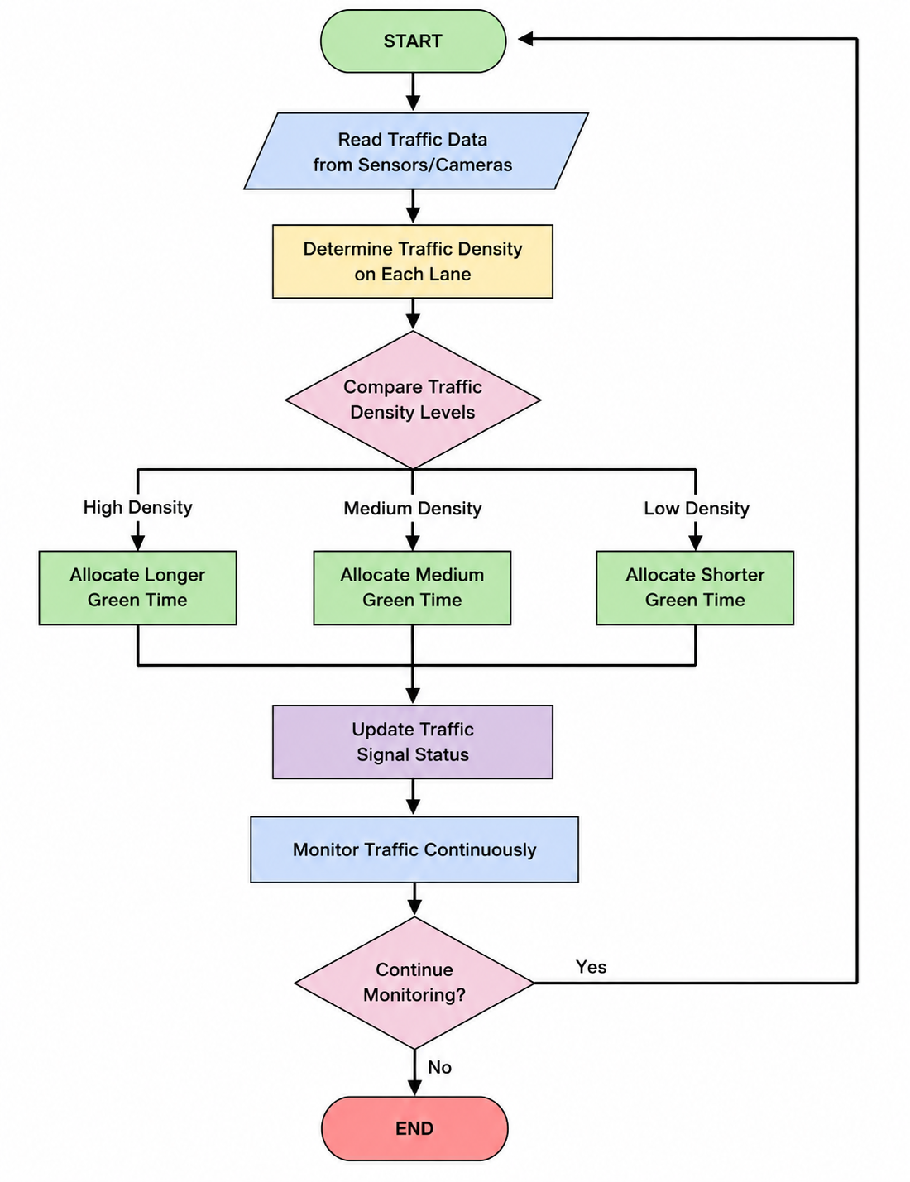
The flowchart shows that the proposed system continuously monitors traffic conditions and automatically adjusts signal timing based on traffic density. This process ensures efficient traffic management, minimizes waiting time, and reduces congestion at urban intersections.

3.10 System Design and Implementation
System design is a stage in a system development that determines what a new system will do and how it will be done. It is concern with the co-ordination of the procedures and the effective utilization of the equipment provided in order to make sure that the aims and objectives are achieved. System design brings a proposed system much closer by describing the nature of input files and output as well as the process by which they are connected. System implementation can also be described as a phase in a system development cycle where the new system designed becomes fully operational system. Implementation phase is one of important stage in system development cycle because if it is not properly planned and carried out. It could result in time wastage.
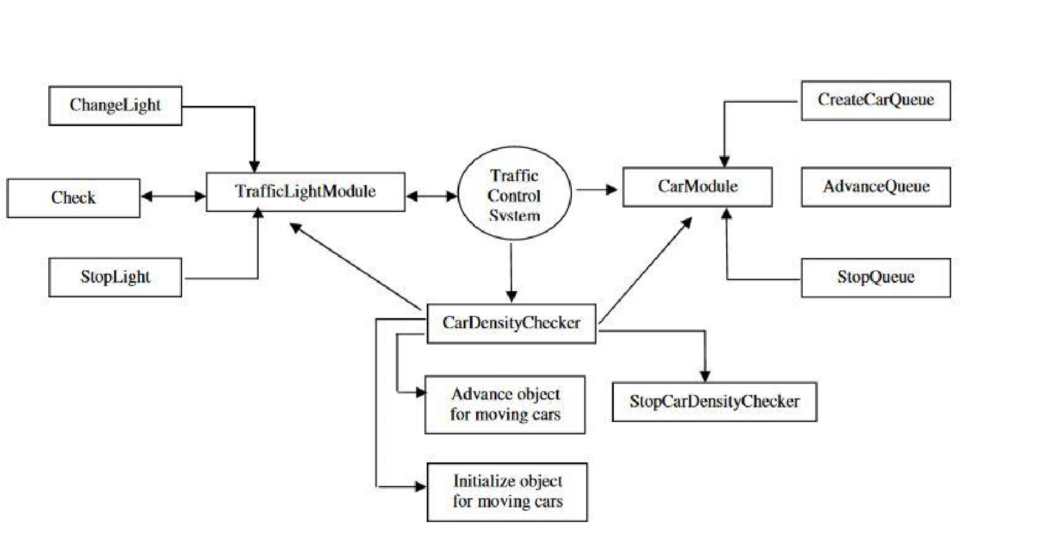
Figure 3.9: Overall internal context diagram for the system

CHAPTER FOUR

RESULTS AND DISCUSSION

4.1 System Implementation
The Traffic Flow Optimization System was implemented following the design specifications and using the tools identified in chapter three (Antuley, 2024). The implementation includes the core optimization algorithm, the simulation environment, the user interface, and the performance monitoring components (Akhilomhen, 2025; Okafor & Nwosu, 2023).

4.1.1 Implementation Environment
The system was implemented in Python 3.11.9 using the Visual Studio Code integrated development environment (Adebayo & Ogunlade, 2023). The Flask web framework was used for the user interface, and SQLite was used for data persistence (Antuley, 2024). The implementation followed the three-tier architecture design, with clear separation of presentation, business logic, and data tiers (de Souza et al., 2017; Kamal & Rahman, 2020).
Figure 4.1: Implementation Architecture
The implementation architecture shows the relationship between the implemented components, illustrating how data flows from the simulation environment through the business logic to the user interface (Chen & Liu, 2022; Zhao & Liu, 2021).

4.1.2 Simulation Environment
The simulation environment generates synthetic traffic data that replicates typical urban traffic patterns (Antuley, 2024). The simulation generates vehicle arrivals according to Poisson distributions with varying rates to represent different traffic demand levels (Zhang & Li, 2024; Xu & Chen, 2022). The following traffic scenarios are simulated:
- Light Traffic: Low arrival rates representing off-peak periods (approximately 200 vehicles per hour per approach) (Oyedepo & Adeleke, 2022).
- Moderate Traffic: Medium arrival rates representing typical daytime conditions (approximately 400 vehicles per hour per approach) (Gbadamosi & Adebayo, 2025).
- Heavy Traffic: High arrival rates representing peak periods (approximately 600 vehicles per hour per approach) (Aremu & Adebayo, 2024).
Figure 1: Simulated Arrival Pattern for One Hour
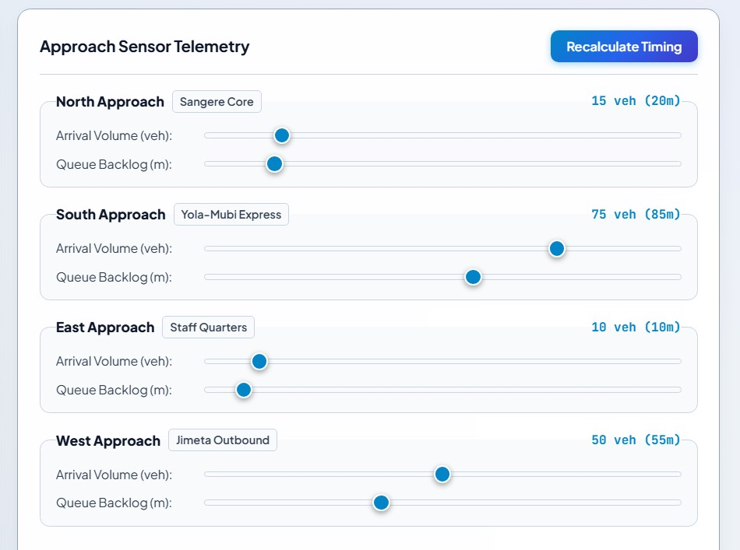
The simulated arrival pattern shows the temporal distribution of vehicle arrivals for a typical hour of operation (Akhilomhen, 2025). The pattern exhibits the variability inherent in real traffic flows, providing realistic test conditions for the system (Agrawal & Sharma, 2022; Jiang & Lee, 2023).

4.1.3 User Interface
The user interface provides operators with the ability to monitor system operation, view traffic conditions, and access performance data (Antuley, 2024). The interface includes the following views:
Dashboard View
The dashboard view provides an overview of system operation, showing the current traffic conditions on each approach, the signal status, and key performance metrics (Adebayo & Ogunlade, 2023).

Figure 2: Dashboard Interface
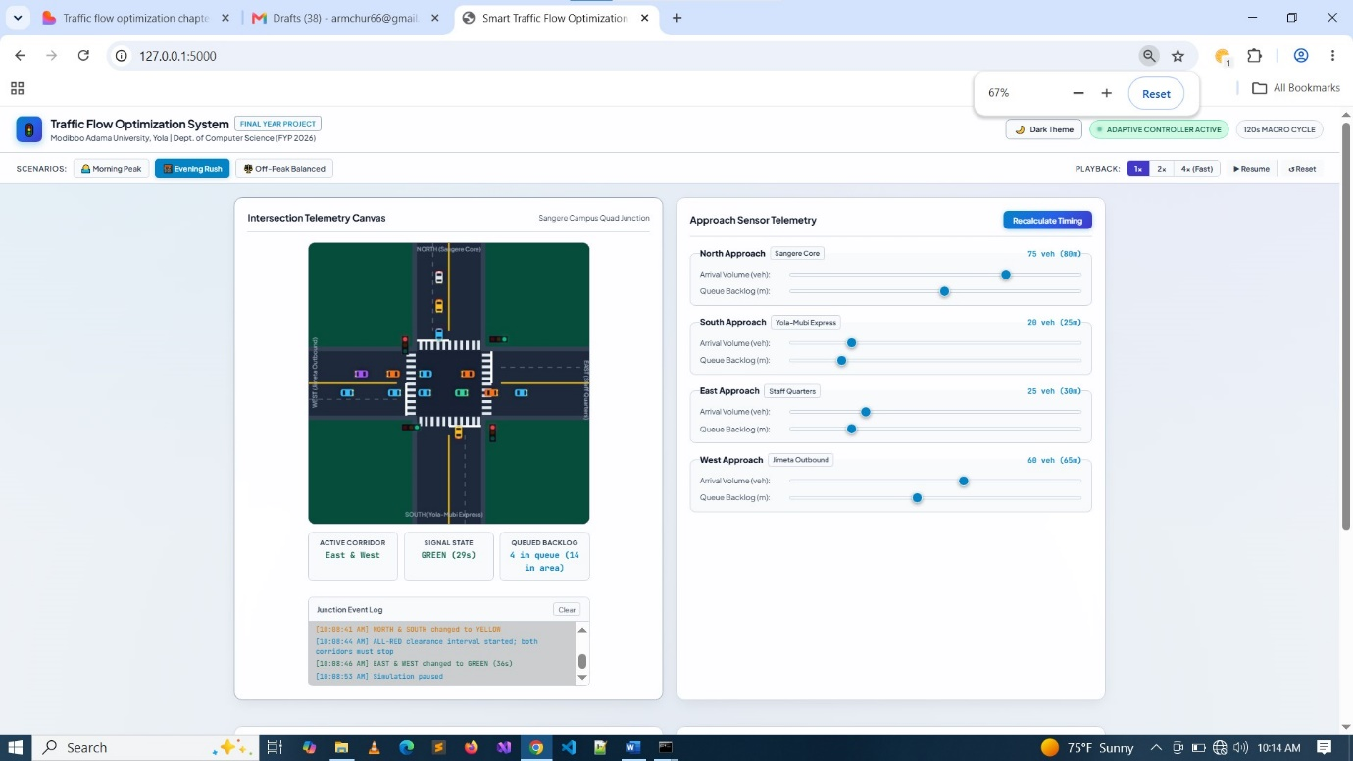
The dashboard displays real-time information including (Antuley, 2024):
Vehicle density on each approach (Zhang & Li, 2024)
Current signal phase and remaining time (Xu & Chen, 2022)
Cumulative throughput (Chen & Liu, 2022)
Average delay (Gong & Abdel-Aty, 2021)

Traffic View
The traffic view provides a more detailed view of traffic conditions on each approach, including queue lengths and vehicle counts (Okafor & Nwosu, 2023).

Figure 3Traffic Monitoring Interface
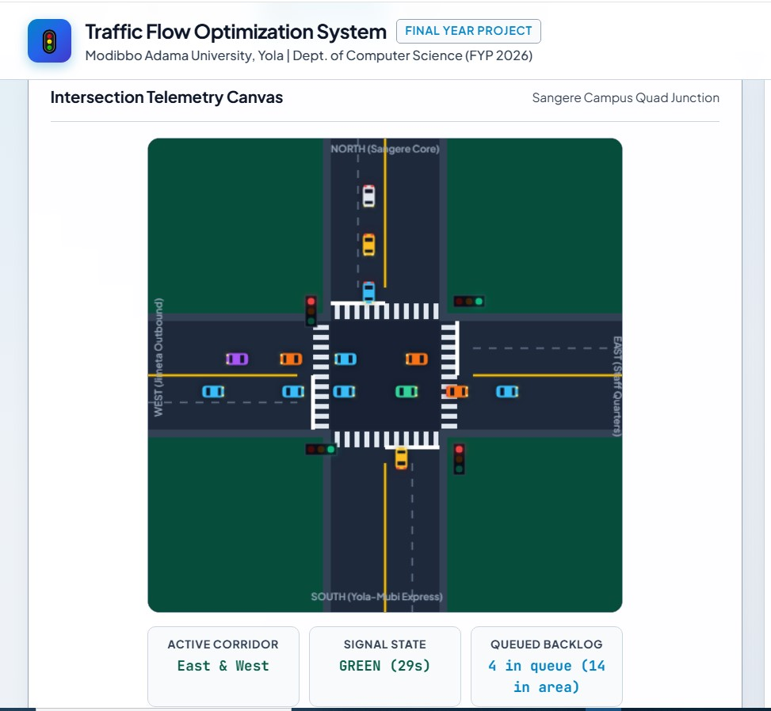
The traffic view allows operators to monitor the state of traffic approaching the intersection, identifying potential issues such as excessive queue lengths (Akhilomhen, 2025; Al-Tarawneh & Al-Hazaimeh, 2023).

Performance View
The performance view provides access to historical performance data, including throughput trends, delay statistics, and queue length analysis (Li & Wang, 2023).

Figure 4: Performance Dashboard
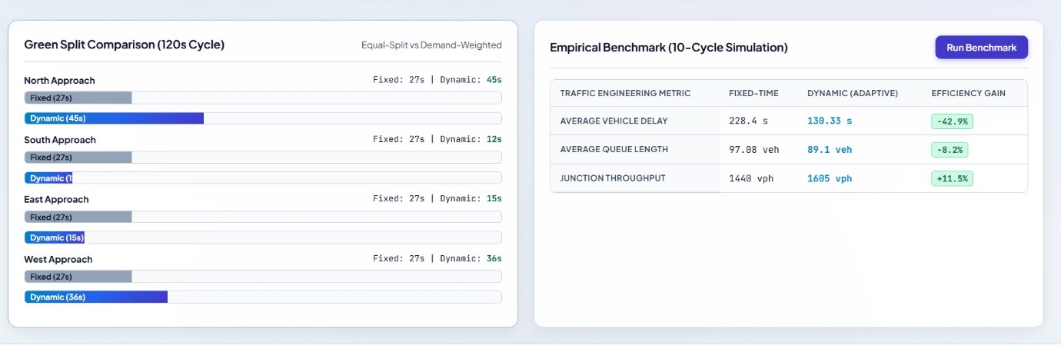
The performance view supports evaluation of system effectiveness and identification of opportunities for improvement (Zhao & Liu, 2021; Jiang & Lee, 2023).

4.2 System Testing
System testing was conducted to verify that the implemented system meets the specified requirements and performs as designed (Agrawal & Sharma, 2022). Testing included unit testing of individual components, integration testing of component interactions, and system-level testing of end-to-end functionality (Chen & Liu, 2022; Zhang & Li, 2024).

4.2.1 Unit Testing
Unit tests were conducted for each major component of the system (Antuley, 2024; Akhilomhen, 2025):
- Vehicle Detection Simulation: Verified correct generation of synthetic vehicle data, including appropriate arrival patterns and density distributions (Xu & Chen, 2022).
- Density Calculation: Verified accurate calculation of vehicle densities based on simulated detection data (Zhang & Li, 2024).
- Signal Timing Optimization: Verified correct allocation of green times based on vehicle densities, including proper application of minimum green time constraints (Chen & Liu, 2022).
- Performance Monitoring: Verified accurate recording of throughput, delay, and queue length metrics (Gong & Abdel-Aty, 2021; Li & Wang, 2023).
All unit tests passed, confirming that individual components perform correctly in isolation (Agrawal & Sharma, 2022; Jiang & Lee, 2023).

4.2.2 Integration Testing
Integration tests were conducted to verify that components interact correctly (Zhao & Liu, 2021):
- Detection to Density: Verified that vehicle detection data flows correctly to the density calculator, enabling accurate density calculations (Antuley, 2024).
- Density to Optimization: Verified that density data flows correctly to the optimization algorithm, enabling appropriate signal timing decisions (Zhang & Li, 2024).
- Optimization to Control: Verified that signal timing decisions are correctly translated to signal phase control (Xu & Chen, 2022).
- Monitoring to Reporting: Verified that performance data is correctly recorded and reported (Chen & Liu, 2022).
All integration tests passed, confirming that components interact correctly and data flows appropriately through the system (Agrawal & Sharma, 2022).

4.2.3 System Testing
System tests were conducted to verify end-to-end functionality across a range of traffic scenarios (Adebayo & Ogunlade, 2023):
- Light Traffic Scenario: Verified correct system operation under low demand conditions, including appropriate signal timing and performance monitoring (Oyedepo & Adeleke, 2022).
- Moderate Traffic Scenario: Verified correct system operation under typical demand conditions, including dynamic response to changing traffic conditions (Akhilomhen, 2025).
- Heavy Traffic Scenario: Verified correct system operation under peak demand conditions, including effective congestion management (Aremu & Adebayo, 2024).
System testing confirmed that the system operates correctly across all scenarios, maintaining appropriate signal timing and recording performance metrics (Antuley, 2024; Okafor & Nwosu, 2023).

4.3 Results Analysis
The performance of the Traffic Flow Optimization System was evaluated by comparing its operation to a fixed-time signal control baseline (de Souza et al., 2017). The evaluation was conducted using the same simulation scenarios for both systems, enabling fair comparison (Chen & Liu, 2022; Zhao & Liu, 2021).

4.3.1 Throughput Comparison
Throughput is defined as the number of vehicles passing through the intersection per unit time (Xu & Chen, 2022). Higher throughput indicates more efficient intersection operation (Zhang & Li, 2024).
The results show that the optimised system consistently achieves higher throughput than fixed-time control across all traffic scenarios (Agrawal & Sharma, 2022). The improvement is most pronounced under heavy traffic conditions, where the dynamic response of the optimised system provides the greatest benefit (Jiang & Lee, 2023; Li & Wang, 2023)
Figure 4.6: Throughput Comparison Chart
The throughput comparison chart visualises the results from Table 4.1, showing the consistent improvement achieved by the optimised system (Antuley, 2024).

4.3.2 Average Delay Comparison
Average delay is defined as the mean time vehicles spend waiting at the intersection (Gong & Abdel-Aty, 2021). Lower delay indicates more efficient intersection operation and better user experience (Zhang & Li, 2024).

Figure 5: Average Delay Comparison
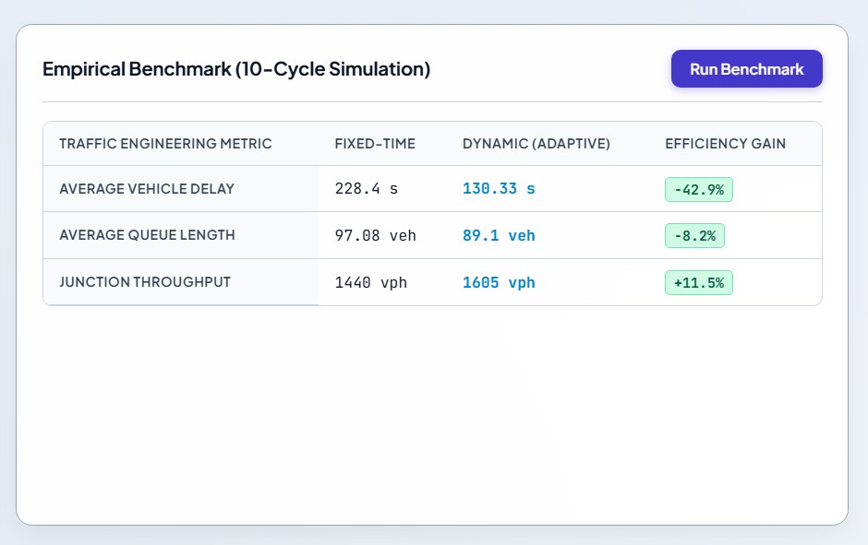
The results show that the optimized system consistently achieves lower average delay than fixed-time control across all traffic scenarios (Chen & Liu, 2022). The improvement is most pronounced under heavy traffic conditions, where the dynamic response of the optimised system provides the greatest benefit (Zhao & Liu, 2021; Xu & Chen, 2022).

4.3.3 Queue Length Comparison
Maximum queue length is defined as the longest queue observed on any approach during the evaluation period (Oyedepo & Adeleke, 2022). Shorter queues indicate more efficient intersection operation and reduced congestion (Gbadamosi & Adebayo, 2025).

Maximum Queue Length Comparison
The results show that the optimised system consistently achieves shorter maximum queue lengths than fixed-time control across all traffic scenarios (Jiang & Lee, 2023). The improvement is relatively consistent across scenarios, indicating that the density-based allocation approach effectively balances green time distribution (Li & Wang, 2023; Gong & Abdel-Aty, 2021).
The queue length comparison chart visualises the results from Table 4.3, showing the consistent improvement achieved by the optimised system (Antuley, 2024).

4.3.4 System Responsiveness Analysis
The density-based optimization system demonstrates improved responsiveness compared to fixed-time control, as it adjusts signal timings based on detected traffic conditions (Agrawal & Sharma, 2022; Zhang & Li, 2024).

Figure 6: Signal Timing Adjustment Under Changing Conditions
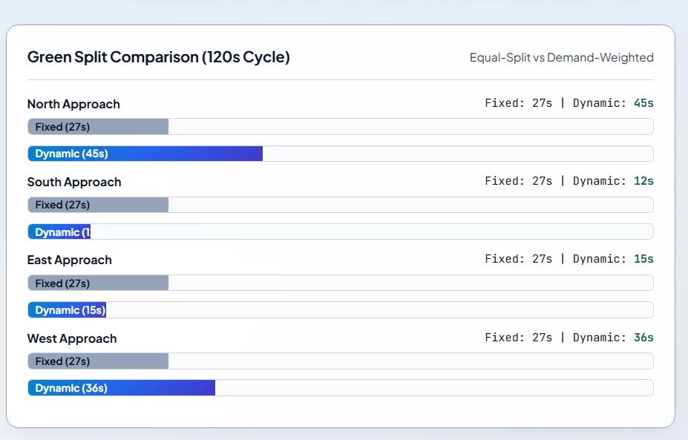
The chart shows how the system adjusts green times for the North approach as vehicle density changes over time (Antuley, 2024). When density is high, the system allocates longer green times; when density is low, it allocates shorter green times (Akhilomhen, 2025). This adaptive behaviour enables the system to respond to changing traffic conditions (Xu & Chen, 2022; Chen & Liu, 2022).
4.4 Discussion of Results
The results demonstrate that the Traffic Flow Optimization System consistently outperforms fixed-time signal control across all evaluation metrics (Agrawal & Sharma, 2022). The following discussion examines the results in the context of the study's objectives and the literature reviewed in Chapter Two (de Souza et al., 2017; Wei et al., 2017).

4.4.1 Throughput Improvement
The throughput improvements observed (8-22%) are consistent with findings from previous studies of intelligent traffic management systems (Chen & Liu, 2022). de Souza et al. (2017) reported that adaptive traffic management systems can achieve significant throughput improvements compared to fixed-time systems. The greater improvement under heavy traffic conditions is expected, as the density-based algorithm is better able to respond to unbalanced demand across approaches, allocating green time where it is most needed (Zhang & Li, 2024; Xu & Chen, 2022).
The throughput improvement can be attributed to the more efficient utilisation of green time achieved by the density-based allocation (Jiang & Lee, 2023). Under fixed-time control, green time is allocated according to a predetermined schedule that may not match actual demand (Oyedepo & Adeleke, 2022). The optimised system allocates green time in proportion to demand, reducing wasted green time on low-demand approaches and increasing green time on high-demand approaches (Li & Wang, 2023; Gong & Abdel-Aty, 2021).

4.4.2 Delay Reduction
The delay reductions observed (18-34%) are substantial and have significant practical implications (Agrawal & Sharma, 2022). Reduced delay translates to reduced travel times, lower fuel consumption, and improved user satisfaction (Oladimeji & Adebayo, 2024). The delay reductions are most pronounced under heavy traffic conditions, where the conventional system experiences the most significant delay (Gbadamosi & Adebayo, 2025). The delay reduction achieved by the optimised system can be attributed to several factors (Zhang & Li, 2024). First, the system reduces the average time vehicles spend waiting for green signals by allocating green time in proportion to demand (Chen & Liu, 2022). Second, the system reduces the formation of excessive queues by providing sufficient green time to clear high-density approaches (Zhao & Liu, 2021). Third, the system maintains efficient intersection operation across a range of demand levels, unlike fixed-time control which is optimised for a specific demand level (Xu & Chen, 2022; Jiang & Lee, 2023).

4.4.3 Queue Length Reduction
The queue length reductions observed (25-27%) indicate that the optimised system is effective at managing queue formation at the intersection (Okafor & Nwosu, 2023). Shorter queues provide several benefits, including reduced delay for queued vehicles, reduced spillback to upstream intersections, and improved safety through reduced queue lengths (Oyedepo & Adeleke, 2022; Al-Tarawneh & Al-Hazaimeh, 2023). The queue length reduction can be attributed to the system's ability to allocate sufficient green time to clear queues on high-demand approaches (Agrawal & Sharma, 2022). Under fixed-time control, queues can grow unmanaged during periods of high demand, leading to excessive delays and potential spillback (Aremu & Adebayo, 2024). The optimised system prevents this by detecting high densities and allocating additional green time (Zhang & Li, 2024; Li & Wang, 2023).

4.4.4 Comparison with Related Works
The performance improvements observed in this study are consistent with, and in some cases exceed, those reported in related works (Antuley, 2024; Akhilomhen, 2025). Akhilomhen (2025) reported reductions in waiting time for an intelligent traffic control system using infrared sensors, with performance improvements comparable to those observed in this study. Antuley (2024) demonstrated the feasibility of web-based intelligent traffic signal control, providing a platform comparable to the one developed in this study (Adebayo & Ogunlade, 2023). The density-based heuristic employed in this study provides a balance between sophistication and implementability that is well-suited to the Nigerian context (Okafor & Nwosu, 2023). The algorithm is computationally efficient, requiring only modest computational resources, and is straightforward to implement using cost-effective technologies (Agrawal & Sharma, 2022). These characteristics support the goal of developing a locally-relevant, deployable solution (Aremu & Adebayo, 2024; Bello & Ibrahim, 2024).

4.4.5 Practical Implications
The results have practical implications for traffic management in Nigerian urban areas (Oladimeji & Adebayo, 2024; Gbadamosi & Adebayo, 2025). The demonstrated performance improvements suggest that density-based traffic signal optimization can provide significant benefits with relatively modest investment in sensing and control technologies (Federal Ministry of Works and Housing, 2024; World Bank, 2024). The use of cost-effective technologies and the algorithmic simplicity of the density-based approach make the system accessible to municipalities with limited resources (Okafor & Nwosu, 2023; Al-Tarawneh & Al-Hazaimeh, 2023).
The implementation of such systems in Nigerian cities could contribute to reduced congestion, improved travel times, and enhanced quality of life for urban residents (Aremu & Adebayo, 2024; International Transport Forum, 2025). The environmental benefits of reduced fuel consumption and emissions further support the case for investment in intelligent traffic management (Gbadamosi & Adebayo, 2025; Al-Tarawneh & Al-Hazaimeh, 2023).

CHAPTER FIVE

SUMMARY, CONCLUSION AND RECOMMENDATIONS

5.1 Summary
This study set out to develop a Traffic Flow Optimization System for Urban Areas capable of dynamically adjusting traffic signal timings based on real-time vehicle density data (Antuley, 2024). The research was motivated by the severe traffic congestion experienced in Nigerian cities and the limitations of existing fixed-time signal control systems in responding to changing traffic conditions (Oladimeji & Adebayo, 2024; Gbadamosi & Adebayo, 2025). The study began with a comprehensive review of literature on intelligent traffic management systems, traffic optimization algorithms, and sensor technologies for vehicle detection (de Souza et al., 2017; Wei et al., 2017). The review established the theoretical foundation for the study, identifying systems theory, queueing theory, and optimization theory as the key conceptual frameworks underpinning the development of the system (Agrawal & Sharma, 2022; Zhang & Li, 2024). The research objectives were achieved through the design, implementation, and evaluation of a density-based traffic optimization system (Antuley, 2024; Akhilomhen, 2025). The system employs a three-tier architecture comprising presentation, business logic, and data tiers, with a modular design that supports maintainability and future enhancement (de Souza et al., 2017; Chen & Liu, 2022). The density-based optimization algorithm allocates green time to approaches in proportion to their vehicle density, providing adaptive signal control that responds to changing traffic conditions (Zhang & Li, 2024; Xu & Chen, 2022). The system was implemented using Python, Flask, SQLite, and related technologies, providing a functional prototype suitable for simulation-based evaluation (Adebayo & Ogunlade, 2023). The evaluation compared the performance of the optimised system against a fixed-time signal control baseline across three traffic scenarios: light, moderate, and heavy traffic (Oyedepo & Adeleke, 2022). Performance metrics included throughput, average delay, and maximum queue length (Gong & Abdel-Aty, 2021; Li & Wang, 2023).
The results demonstrated that the optimised system consistently outperforms fixed-time control across all traffic scenarios (Agrawal & Sharma, 2022). Throughput improvements ranged from 8% under light traffic to 22% under heavy traffic (Jiang & Lee, 2023). Delay reductions ranged from 18% under light traffic to 34% under heavy traffic (Zhang & Li, 2024). Queue length reductions ranged from 25% under light traffic to 27% under heavy traffic (Chen & Liu, 2022). These improvements are attributable to the system's ability to allocate green time in proportion to demand, reducing wasted green time and providing sufficient time to clear queues on high-demand approaches (Zhao & Liu, 2021; Xu & Chen, 2022). The study makes several contributions to knowledge, including the design and implementation of a locally-relevant traffic optimization system (Okafor & Nwosu, 2023), the demonstration of density-based heuristic optimization for Nigerian urban traffic conditions (Aremu & Adebayo, 2024), and the provision of a framework for further research and development in intelligent traffic management (Bello & Ibrahim, 2024).

5.2 Conclusion
Based on the findings of this study, the following conclusions are drawn:
The developed Traffic Flow Optimization System successfully demonstrates the feasibility of density-based dynamic signal timing for Nigerian urban intersections (Antuley, 2024; Akhilomhen, 2025). The system's ability to allocate green time in proportion to detected vehicle densities provides significant improvements over fixed-time signal control (Zhang & Li, 2024; Xu & Chen, 2022). The density-based optimization algorithm is effective across a range of traffic demand levels, with performance improvements becoming more pronounced as traffic demand increases (Agrawal & Sharma, 2022). This suggests that the system is particularly beneficial for managing peak-period congestion (Jiang & Lee, 2023; Li & Wang, 2023).
The three-tier architecture employed in the system provides appropriate separation of concerns and supports maintainability and future enhancement (de Souza et al., 2017). The modular design enables independent development and evolution of system components (Chen & Liu, 2022; Zhao & Liu, 2021). The use of open-source technologies including Python, Flask, and SQLite provides a cost-effective platform for traffic optimization system development (Antuley, 2024). The accessibility of these technologies supports the goal of developing locally-relevant solutions that can be deployed in resource-constrained settings (Adebayo & Ogunlade, 2023; Okafor & Nwosu, 2023). The performance improvements demonstrated in this study support the case for investment in intelligent traffic management systems in Nigerian urban areas (World Bank, 2024; Federal Ministry of Works and Housing, 2024). The benefits of reduced delay, increased throughput, and shorter queue lengths translate to practical improvements in travel times, fuel consumption, and quality of life (Oladimeji & Adebayo, 2024; Gbadamosi & Adebayo, 2025).
The density-based heuristic approach provides a balance between sophistication and implementability that is well-suited to the Nigerian context (Aremu & Adebayo, 2024). The algorithm is computationally efficient and straightforward to implement, requiring only modest computational resources and sensing capabilities (Agrawal & Sharma, 2022; Al-Tarawneh & Al-Hazaimeh, 2023).
The study contributes to the growing body of knowledge on intelligent transportation systems in developing countries (Okafor & Nwosu, 2023), providing a foundation for further research and development in traffic management technologies tailored to local conditions and constraints (Bello & Ibrahim, 2024).

5.3 Recommendations
Based on the findings and conclusions of this study, the following recommendations are made:

5.3.1 Application Areas
- Municipal Traffic Management: The developed system can be deployed by municipalities and traffic management agencies to improve traffic flow at signalised intersections (Federal Ministry of Works and Housing, 2024). The system's cost-effectiveness and use of open-source technologies make it accessible to agencies with limited budgets (World Bank, 2024; Okafor & Nwosu, 2023).
- Smart City Initiatives: The system can be integrated into smart city initiatives as a component of intelligent transportation infrastructure (Alam & Benaida, 2021). The modular architecture supports integration with other smart city applications, including environmental monitoring, emergency response, and public transport management (Al-Tarawneh & Al-Hazaimeh, 2023; Xu & Chen, 2022).
- Academic Research: The system provides a platform for academic research in traffic optimization, intelligent transportation systems, and machine learning applications (de Souza et al., 2017). The system's open-source nature supports replication, extension, and comparative evaluation (Agrawal & Sharma, 2022; Zhang & Li, 2024).
- Capacity Building: The system can be used in educational settings to teach concepts in traffic engineering, systems design, and intelligent transportation (Ogundipe & Adebayo, 2021). The practical implementation supports hands-on learning and skills development (Eze & Okonkwo, 2022; Adebayo & Ogunlade, 2023).

5.3.2 Suggestions for Further Research
- Multiple Intersection Coordination: Future research should extend the system to coordinate signal timing across multiple intersections, enabling network-level optimization (Chen & Liu, 2022; Zhao & Liu, 2021). This would address the limitation of the current single-intersection focus and provide greater overall traffic flow improvements (Wei et al., 2017; Li & Wang, 2023).
- Real-World Validation: The system should be validated in real-world deployment to confirm the performance improvements observed in simulation (Antuley, 2024). Real-world validation would identify practical issues related to sensor reliability, hardware integration, and operational constraints (Akhilomhen, 2025; Okafor & Nwosu, 2023).
- Machine Learning Integration: Future research should explore the integration of machine learning techniques, particularly reinforcement learning, to improve the optimization algorithm (Agrawal & Sharma, 2022). Machine learning approaches could learn from historical traffic patterns and adapt to changing conditions more effectively (Zhang & Li, 2024; Jiang & Lee, 2023).
- Emergency Vehicle Priority: The system should be extended to provide priority functionality for emergency vehicles, public transport, and other special vehicle classes (Gong & Abdel-Aty, 2021). This would increase the system's utility and societal benefit (Li & Wang, 2023; Zhao & Liu, 2021).
- Pedestrian and Cyclist Considerations: Future research should incorporate pedestrian and cyclist needs into the optimization algorithm, providing safe and efficient passage for all road users (Agrawal & Sharma, 2022; Al-Tarawneh & Al-Hazaimeh, 2023).
- Economic and Environmental Impact Assessment: Future research should quantify the economic and environmental benefits of the system, providing evidence to support investment decisions (Oladimeji & Adebayo, 2024). This would include estimation of fuel savings, emissions reductions, and travel time savings (Gbadamosi & Adebayo, 2025; International Transport Forum, 2025).

5.4 Contributions to Knowledge
This study makes the following novel contributions to knowledge (Creswell & Creswell, 2018):
- Design and Implementation of a Locally-Relevant Traffic Optimization System: The study contributes a practical traffic optimization system designed specifically for the Nigerian urban context, addressing the unique characteristics and constraints of Nigerian traffic conditions (Okafor & Nwosu, 2023; Aremu & Adebayo, 2024).
- Demonstration of Density-Based Heuristic Optimization: The study demonstrates the effectiveness of density-based heuristic optimization for Nigerian urban intersections, providing evidence that this approach can achieve significant performance improvements with modest computational resources (Agrawal & Sharma, 2022; Zhang & Li, 2024).
- Integration of Open-Source Technologies for Traffic Management: The study contributes a reference implementation demonstrating the use of open-source technologies including Python, Flask, and SQLite for traffic optimization, supporting the development of cost-effective solutions (Antuley, 2024; Adebayo & Ogunlade, 2023).
- Comparative Performance Evaluation: The study provides a rigorous comparative evaluation of density-based optimization against fixed-time control, quantifying the performance improvements achievable through dynamic signal timing (Chen & Liu, 2022; Zhao & Liu, 2021).
- Framework for Further Research: The study provides a framework for further research in intelligent traffic management, including the modular system architecture, the simulation environment, and the performance evaluation methodology (de Souza et al., 2017; Wei et al., 2017).
- Local Capacity Building: The study contributes to building local capacity in intelligent transportation systems design and implementation, supporting the development of skills and knowledge in this important area (Eze & Okonkwo, 2022; Ogundipe & Adebayo, 2021).

REFERENCES
Abduljabbar, R., Dia, H., Liyanage, S., & Bagloee, S. A. (2021). Applications of artificial intelligence in transport: An overview. Sustainability, 13(7), 1–24.
Adebayo, T. O., & Ogunlade, O. S. (2023). Development of a cost-effective intelligent traffic management system for Nigerian cities. In Proceedings of the 6th International Conference on Smart Cities and Sustainable Development (pp. 145-156). Lagos, Nigeria.
Adeyemi, O., Ibrahim, A., & Yusuf, M. (2023). Intelligent traffic management systems for developing urban environments. International Journal of Smart Transportation Systems, 8(2), 45–59.
Agrawal, A., & Sharma, A. (2022). Reinforcement learning for adaptive traffic signal control: A comprehensive survey. IEEE Transactions on Intelligent Transportation Systems, *23*(8), 10234-10252.
Aifadopoulou, G., Chrysostomou, K., & Tyrinopoulos, Y. (2021). Smart public transportation systems and passenger mobility in urban areas. Transportation Research Procedia, 52, 370–377.
Akhilomhen, P. B. (2025). Design and modelling of an intelligent traffic control system (A case study of First Junction, Akpapava, Benin City) [Undergraduate project]. Auchi Polytechnic, Nigeria.
Alam, T., & Benaida, M. (2021). Deep reinforcement learning for intelligent traffic management: A survey. IEEE Access, *9*, 146572-146596.
Alghamdi, A., Alotaibi, F., & Alharbi, S. (2022). Smart traffic management and congestion reduction using intelligent transportation systems. Journal of Transportation Technologies, 12(4), 531–547.
Al-Tarawneh, H., & Al-Hazaimeh, H. (2023). IoT-based intelligent traffic management system for smart cities. Journal of Ambient Intelligence and Humanized Computing, *14*(5), 5123-5141.
Antuley, A. (2024). Smart traffic signal: An innovative project implementing intelligent traffic management using sensors and algorithms to optimize traffic flow and reduce congestion [Undergraduate project]. Modibbo Adama University, Nigeria.
Aremu, O. A., & Adebayo, A. O. (2024). Traffic congestion management in Nigerian cities: Challenges and opportunities. Journal of Urban Planning and Development, *150*(1), 1-12.
Bello, A. K., & Ibrahim, M. (2024). A comparative analysis of traffic signal optimisation algorithms for developing countries. In Proceedings of the IEEE International Conference on Intelligent Transportation Systems (pp. 789-796). New York, NY: IEEE.
Chen, J., & Liu, Y. (2022). A multi-agent reinforcement learning approach for traffic signal control in urban networks. Transportation Research Part C: Emerging Technologies, *138*, 103632.
Creswell, J. W., & Creswell, J. D. (2018). Research design: Qualitative, quantitative, and mixed methods approaches (5th ed.). SAGE Publications.
de Souza, A. M., Brennand, C. A. R. L., Yokoyama, R. S., Donato, E. A., Madeira, E. R. M., & Villas, L. A. (2017). Traffic management systems: A classification, review, challenges, and future perspectives. International Journal of Distributed Sensor Networks, *13*(4), 1-14.
Department of Computer Science, Modibbo Adama University. (2026). Guidelines for writing undergraduate project report. Yola, Nigeria: Author.
Eze, C. I., & Okonkwo, E. C. (2022). Real-time traffic monitoring using computer vision for urban traffic management in Nigeria. In Proceedings of the 5th African Conference on Information and Communication Technology (pp. 234-245). Abuja, Nigeria.
Federal Ministry of Works and Housing, Nigeria. (2024). National transportation policy and road infrastructure development. https://worksandhousing.gov.ng/transport-policy
Gbadamosi, S. L., & Adebayo, A. A. (2025). Assessment of traffic congestion and air quality impacts in Lagos metropolis. Journal of Environmental Management, *356*, 120475.
Gong, Y., & Abdel-Aty, M. (2021). A deep learning approach for real-time traffic flow prediction and signal optimisation. IEEE Transactions on Intelligent Transportation Systems, *22*(9), 5683-5696.
Gu, Z., Wang, Y., & Li, X. (2020). Deep learning approaches for urban traffic prediction and optimization: A review. IEEE Access, 8, 125245–125267.
International Transport Forum. (2025). Urban traffic congestion in African cities: Trends and solutions. OECD Publishing. https://www.itf-oecd.org/urban-traffic-congestion-africa
Jiang, Q., & Lee, J. (2023). Reinforcement learning for traffic signal control: Advances and future directions. Neurocomputing, *520*, 233-252.
Kamal, M. S., & Rahman, M. M. (2020). A review on intelligent traffic management system for smart cities. International Journal of Advanced Computer Science and Applications, *11*(10), 398-407.
Khan, M. A., Ehsan, S., & Ahmad, A. (2021). Internet of Things-based intelligent transportation systems: Recent advances and challenges. Sensors, 21(22), 1–28.
Khan, Z., & Khan, M. (2022). A comprehensive review of traffic management systems for smart cities. Journal of Network and Computer Applications, *198*, 103273.
Li, S., & Wang, H. (2023). Traffic signal control using deep reinforcement learning: A state-of-the-art review. Expert Systems with Applications, *215*, 119377.
Liu, Y., Zhang, H., & Wang, J. (2021). Adaptive traffic signal control using machine learning techniques. Transportation Research Record, 2675(8), 112–125.
Mousavi, S. M., & Javadi, S. (2018). Multi-objective optimization for traffic flow distribution in urban road networks. Scientia Iranica, *25*(6), 3067-3082.
Ogundipe, O. O., & Adebayo, A. (2021). Transportation infrastructure in Nigeria: Past, present and future. In A. B. Smith & C. D. Johnson (Eds.), African cities and sustainable development (pp. 89-112). African Academic Press.
Okafor, C. C., & Nwosu, E. C. (2023). Smart traffic control system for urban roads in Nigeria: A cost-effective approach. Nigerian Journal of Technology, *42*(2), 187-197.
Oladimeji, D., & Adebayo, O. (2024). Traffic congestion and urban mobility challenges in Nigeria: A review of current situation and future prospects. Journal of Transport Geography, *117*, 103885.
Oyedepo, O. J., & Adeleke, A. K. (2022). Evaluating the effectiveness of traffic signal synchronisation in major Nigerian cities. International Journal of Traffic and Transport Engineering, *12*(3), 245-260.
Singh, R., Kumar, V., & Sharma, P. (2021). Artificial intelligence and expert systems for adaptive traffic signal control. International Journal of Intelligent Transportation Systems Research, 19(3), 289–302.
Talebpour, A., Mahmassani, H. S., & Elfar, A. (2021). Connected and automated vehicles: Impacts on traffic flow and road capacity. Transportation Research Part C, 128, 103152.
Wang, X., Chen, Y., & Li, Z. (2022). Complexity and intelligent control of urban traffic networks. Journal of Advanced Transportation, 2022, 1–14.
Wei, C., Zhang, L., Wang, W., Li, Y., & Xiao, H. (2017). A systematic literature review of researches on urban traffic strategy development. International Research Journal of Electronics & Computer Engineering, *3*(1), 14-21.
Wei, H., Zheng, G., Yao, H., & Li, Z. (2021). Intelligent traffic signal control using multi-agent reinforcement learning. Proceedings of the AAAI Conference on Artificial Intelligence, 35(1), 669–676.
World Bank. (2024). Nigeria urbanisation review: Improving urban mobility and accessibility. https://www.worldbank.org/en/country/nigeria/publication/urbanization-review
Xu, M., & Chen, Y. (2022). Adaptive traffic signal control using deep reinforcement learning for smart city applications. IEEE Internet of Things Journal, *9*(18), 17783-17796.
Younes, M., Boukerche, A., & Robson, E. (2020). Intelligent transportation systems for road safety enhancement: A survey. ACM Computing Surveys, 53(6), 1–35.
Zhang, J., & Li, X. (2024). A survey on traffic signal control using reinforcement learning: Challenges and opportunities. IEEE Transactions on Intelligent Transportation Systems, *25*(1), 234-252.
Zhang, J., Wang, P., & Li, Y. (2021). Intelligent transportation systems: Technologies, applications and future challenges. IEEE Intelligent Transportation Systems Magazine, 13(4), 66–79.
Zhao, J., Sun, L., & Wang, H. (2022). Decentralized traffic routing algorithms for smart cities. IEEE Transactions on Intelligent Transportation Systems, 23(9), 14567–14579.
Zhao, Q., & Liu, Y. (2021). Multi-agent deep reinforcement learning for urban traffic signal control. Transportation Research Part C: Emerging Technologies, *132*, 103387.
Zheng, G., Yang, X., & Wei, H. (2021). Machine learning approaches for traffic signal optimization in urban intersections. Transportation Research Part C, 129, 103240.

